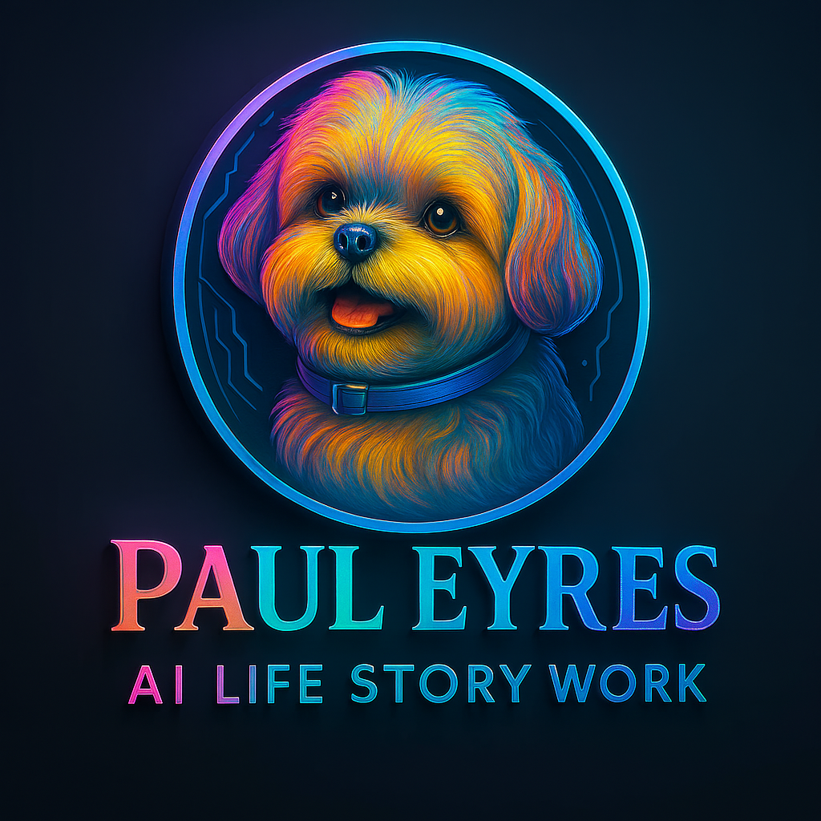
Client Questionnaire for Your Life Story Report
Use this form to give us all the details we need to craft a Life Story Report that perfectly reflects your vision. Feel free to skip any questions that don’t apply or add extra notes where helpful.
EDIT IT, SAVE IT, AND EMAIL IT
1. Project Overview
- What is the working title of your Life Story Report?
- What is the primary purpose (e.g., family keepsake, memorial tribute, professional legacy)?
- What are your top three objectives for this report?

2. Subject and Client Details
- Full name of the subject and any nicknames you’d like included
- Date and place of birth (and, if applicable, date of passing)
- Key locations and residences throughout their life
- Immediate family members (spouse, children, siblings) and important relationships
- Your name, role, and contact information

3. Target Audience and Accessibility
- Who is the primary reader? (e.g., grandchildren, community group, online audience)
- What age group should the writing be aimed at?
- Are there any known accessibility needs or disabilities (e.g., large print, dyslexia-friendly font)?
- Will the report require translation or multilingual sections?

4. Content Scope: Topics to Include or Exclude
- List the major life stages or events you want covered (childhood, career, military service, retirement, etc.)
- Which achievements, anecdotes, or turning points are essential?
- Are there any sensitive topics or events you prefer us to omit or handle with care?
- Would you like contextual history or timeline sidebars?

5. Writing Style, Tone, and Perspective
- Preferred narrative style: memoir (first-person), biography (third-person), or hybrid
- Tone: formal, conversational, inspirational, humorous, reflective, etc.
- Do you have examples of writing styles you love (e.g., excerpts or favorite authors)?
- How many rounds of revisions would you like before final sign-off?

6. Visual Elements and Imagery
- Will you provide original photos, drawings, or artifacts? Please list filenames and suggested placement.
- What additional images would you like us to create? For each, describe the scene, subjects, setting, and mood.
- Do images need captions, credits, or thematic overlays (maps, quotes, timelines)?
- Preferred treatment: full-color, black-and-white, sepia, or stylized illustration?

7. Format, Design, and Layout
- Desired page count (e.g., 25 pages) and overall report dimensions (A4, letter)
- Any branding or design guidelines (fonts, color palette, logo placement)
- Should there be section dividers, headers/footers, and page numbering?
- Do you want a cover page, table of contents, or dedication page?

8. Project Timeline and Delivery
- What is your target completion date?
- Are there milestone deadlines (e.g., first draft, image proofing)?
- Preferred file format(s) for drafts and final deliverables (Word, PDF, print-ready PDF)?
- Who will be the primary point of approval on your side?

9. Budget, Pricing, and Additional Services
- What is your budget range for this project?
- Are you interested in related services (audio narration script, video storyboard, printed book printing)?
- Would you like guidance on printing options or distribution channels?

10. Permissions, Copyright, and Confidentiality
- Do you have usage rights or permissions for all provided photos, text, and artifacts?
- Are there any privacy concerns or NDAs we should be aware of?
- Should we include a disclaimer or copyright notice in the final report?

11. Anything Else?
- Is there any additional information, special requests, or personal anecdotes you’d like to share?
- Are there quotes, poems, or family mottos you want woven into the narrative?
- Do you have questions about our process or how we’ll collaborate?

Thank you for providing these details. Once we receive your responses, we’ll draft a project outline and timeline, then schedule our first call to bring your Life Story Report to life.

