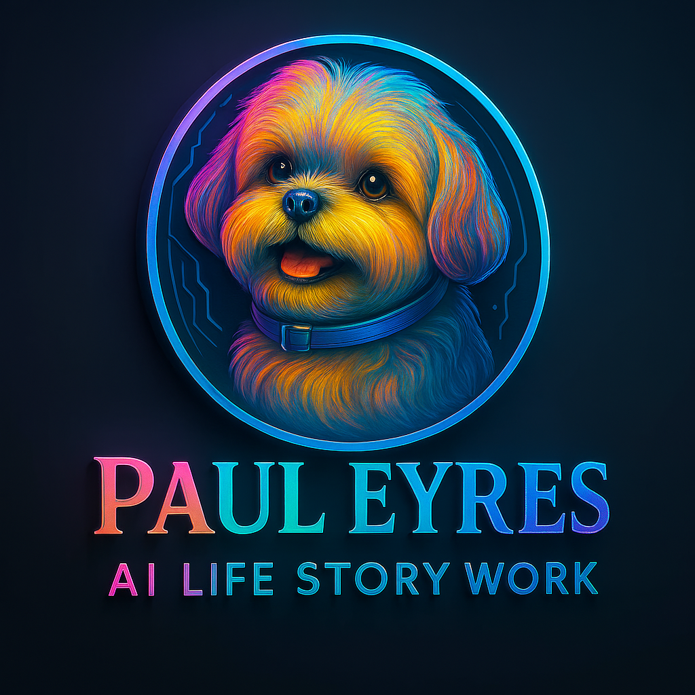
EDIT IT, SAVE IT, EMAIL IT!

📝 Life Story & Genogram Questionnaire
Thank you for choosing to create a family keepsake. This form is designed to help us understand your vision, preferences, and requirements so we can tailor the project perfectly to you and your loved ones.

1. 👶 Intended Recipient
- Who is the report or genogram being created for?
- What is their age, or target age range?
- Are there any sensory, cognitive, or learning needs to consider (e.g., visual impairments, memory issues, accessibility preferences)?

2. 🧬 Scope of the Life Story
- Which family members would you like to include?
(Please list names and relationships)
- How many pages or sections per person would you prefer?
  - ☐ 1 page
  - ☐ 2–3 pages
  - ☐ More — please specify:
- Would you like to include pets, friends, or non-family caregivers?

3. 📖 Themes and Content
What should be covered?
- ☐ Chronological life history
- ☐ Major milestones (births, weddings, retirements)
- ☐ Memorable family traditions
- ☐ Personality traits, hobbies, quirks
- ☐ Historical context (e.g. wartime memories, cultural background)
- ☐ Personal messages (see section 7)
- ☐ Other — please describe:

4. 🖼️ Visual Elements
Would you like to include:
- Supplied actual photographs?
  - ☐ Yes — format: ___________
  - ☐ No
- AI-generated creative images?
  - ☐ Yes — of what subjects? (e.g. “Dad fixing his motorbike”, “Grandma baking with the children”):
- Preferred image style:
  - ☐ Realistic photograph
  - ☐ Artistic sketch or painting
  - ☐ Vintage/sepia effect
- Desired image size/placement:
  - ☐ Full-page
  - ☐ Half-page
  - ☐ Inline with text
  - ☐ Captioned

5. 🧱 Layout & Format Preferences
- Preferred tone of writing:
  - ☐ Warm and nostalgic
  - ☐ Playful and light-hearted
  - ☐ Formal and respectful
  - ☐ First-person perspective
  - ☐ Third-person narrative
- Preferred document format:
  - ☐ Digital only (PDF)
  - ☐ Printable version
  - ☐ Bound book layout
- Do you want the project to include:
  - ☐ Title page
  - ☐ Table of contents
  - ☐ Dedication or foreword
  - ☐ Page numbers

6. ✏️ Additional Details
Are there disabilities, language preferences, cultural considerations, or sensitive topics we should be aware of or handle with extra care?

7. 💌 Personal Messages
Would you like to include personal messages from:
- ☐ Yourself
- ☐ Children or grandchildren
- ☐ Spouse or partner
- ☐ Other family members
If yes, please provide any messages you'd like included or indicate you'd like us to help draft them.

8. 🔁 Future Additions
Would you like this project to be:
- ☐ A one-time keepsake
- ☐ Part of a growing family record (with future updates)

9. 📅 Timeline
What is your ideal completion date or timeframe?

10. ✅ Final Touches
Any other requests, preferences, or creative ideas you'd like to share?

If you'd like, I can help you format this beautifully for printing or presentation. Or I can help build out companion pages, like a welcome message or sample biography template. Just let me know which direction you'd like to take next!

